Test cases fix for admin:

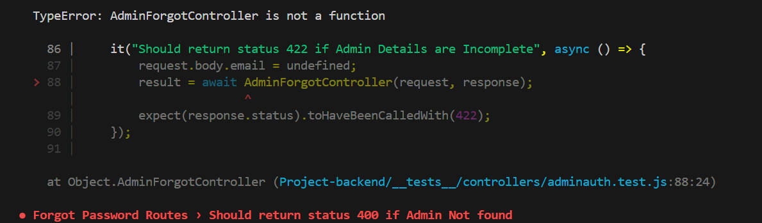
Issue:
Return Statement Issue with res.status() and res.json() In the controller, the following syntax
return res.status(422), res.json({ message: 'Please fill all fields' });
Resolution:
res.status() and res.json() to ensure that both are executed as expected:
return res.status(422).json({ message: 'Please fill all fields' });

